Project Report

Automated Stock Exchange System

To construct our code, we begin by initiating an empty dictionary for user profiles and
empty lists for buy orders and sell orders to store input data. Next, the defined function
“record_transaction” is constructed to include necessary parameters that will record a dictionary
of inputs and convert that entered data into string format (by using json.dumps(log_entry) to
write it into the “execution_log.txt” file.

We created three separate classes for user profile, buy orders, and sell orders followed by
the three respective defined functions to register a user, place a buy order, and place a sell order.
The class UserProfile and defined “register_user” function are created to fulfill “a. Create an
account”. This class gives the user a unique ID generated from the uuid library imported at the
beginning of the code as well as stores the inputs for full name and email address to the instance
attributes when calling the “register_user” function. The user inputs that are stored in the local
variables will be demonstrated below when creating an object for UserProfile. The BuyOrder
class and defined “place_buy_order” function prompts the user to enter the unique ID generated
for the user upon account creation and enter information about the stock to be purchased (asset
symbol of stock, bidding price, and desired amount) then stores it into the BuyOrder class which
appends the inputs to the global buy_orders list initialized at the beginning. Similarly, the
SellOrder class and defined “place_sell_order” function prompts the user to input the same
information with a differentiation in order_price (bidding for buying order, asking for selling
order). Lastly, the defined “terminate_application” function uses the “sys.exit()” fuction from the
sys library imported at the start to exit the program when selected. The codes of the system explained thus far leads us to the creation of the main menu in the defined
“display_main_interface” function that prompts the user to enter an action (user registration,
placing a buy order, placing a sell order, or exiting the program). The main menu is presented as
an infinite loop using the “while” function until “d. Exit the program” is selected. Since inputs
are case sensitive, we apply the “.lower()” function to convert the menu inputs to lowercase
ensuring seamless menu selection.

The following three defined functions of the program checks for matches between
bidding prices and asking prices executing the order immediately when a match is detected. The
defined “process_exact_match” with the “buy_order” and “sell_order” parameters processes
successful matches between a bidding and asking price. When this function executes, the
transaction is recorded into the defined “record”transaction” dictionary that writes the data into
the “execution_log.txt” file and removes it from the global variables “buy_orders” list as well as
the “sell_orders” list. The “process_partial_buy” defined function addresses the scenario when
the asking price is greater than the bidding price, the function prints the quantity of buy orders
and the price at which it executes. It records the transaction and updates the quantity of the sell
order by removing the buy order quantity from it and removes the buy order from the
“buy_orders” list. Likewise, in the “process_partial_sell” function, if the bidding price is greater
than the asking price, the function prints the quantity of sell orders executed at the relative
bidding price. The quantity of the buy order is removed from the sell order and the global
variable “sell_orders” list. The final portion of the program defines the “evaluate_orders”
function. We iterate through the “buy_orders” list and the “sell_orders” list implementing list
slicing to compare the two lists to each other (for matching) based upon what has been stored
into those global variables. This function is utilized to help fulfill orders when matches are found
executing the functions discussed above (processing exact matches, partial buys, or partial sales).

For the first scenario, we begin by creating two different accounts that will be used to
process a match between a buy order and a sell order. After entering first/last name and email
address you are given a uniquely generated user ID.
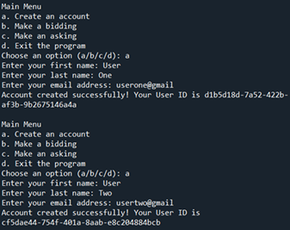

Alternatively, you can write a code to create object instances of the UserProfile class using
UserProfile(given_name, family_name, email_address) to store the inputs; in this case,
UserProfile(User, One, userone@gmail) and UserProfile(User, Two, usertwo@gmail). Next, we
will have User One place a buy order and have User Two place a sell order using the generated
unique IDs respectively to process a match. As seen below, after User Two enters the stock
information, the 10 orders are successfully processed as an exact match executing at the equal
bidding and asking prices.
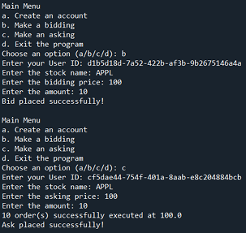

For the second scenario, after creating two accounts for comparison, we enter inputs for
User One’s bidding and User Two’s asking to satisfy the conditions of the partial buy order
showing that the process of transaction for the buy order quantity will execute at the buy order
quantity when the sell order quantity exceeds the quantity of the buy order. For User One, we
enter the stock information and set the quantity to 50. For User Two, we enter the stock
information but with an asking amount (75) higher than the bidding amount (50). This
successfully executes the bidding amount as it fulfills the partial buy order.
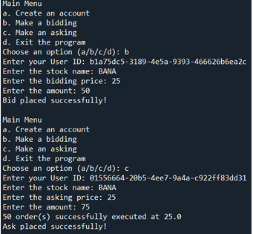

In the third and final scenario, the two user inputs will execute at the asking quantity
when the bidding amount exceeds the asking amount as pictured below. User One enters the
stock information at a bidding amount of 100 while User Two enters at an asking amount of 75.
Since the bidding amount is greater than the asking amount, the order successfully satisfies the
partial sell order conditions.

